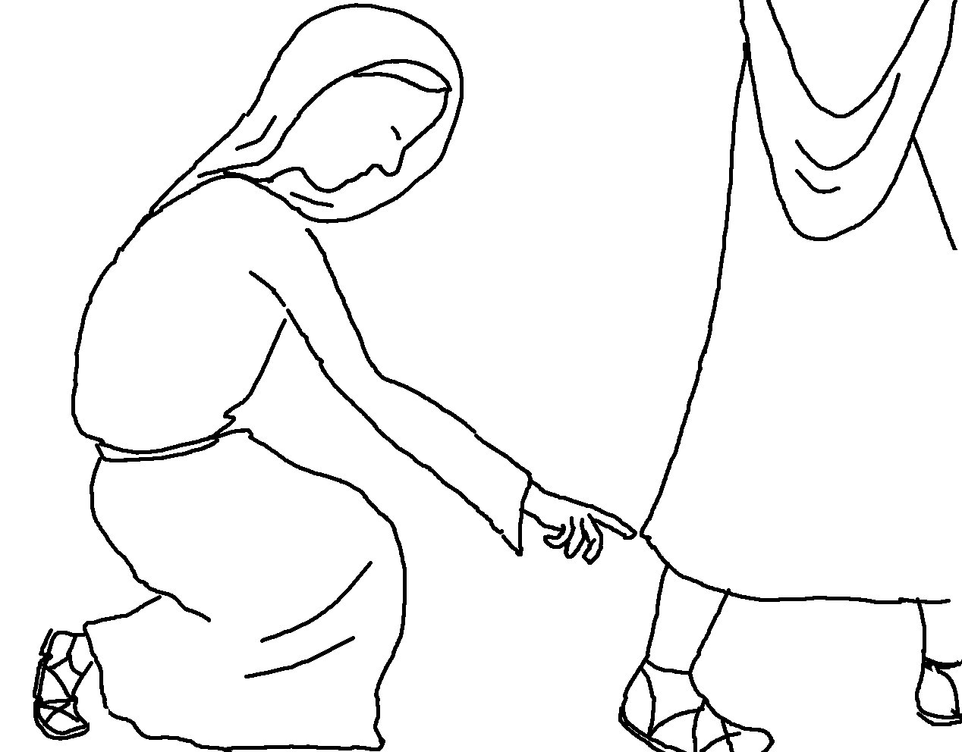

"Your faith has made you well."
Matthew 9:22 _{NLT}

